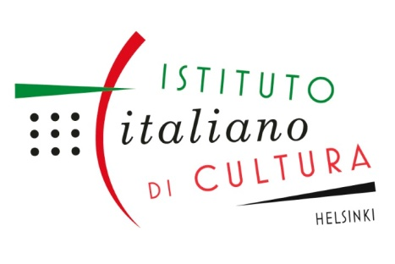
Italian Cultural Institute - Helsinki

Registration form

Italian language and culture courses
Please fill in the form below and e-mail it to: corsi.iichelsinki@esteri.it
You can also mail it or drop it at the office.

Course venue: Ullankatu 3 A 2, 00140 Helsinki

Office: Vuorimiehenkatu 11 B 10, 00140 Helsinki
Tel. (09) 6811 330 - https://iichelsinki.esteri.it/iic_helsinki/fi/

Name:
Address:
Phone number:
E-mail:
I would like to sign up for the following course/courses:

Course name/level:
Time:
Teacher:
Further information:

☐ Yes, I wish to join the mailing list of the Italian Cultural Institute and receive information about upcoming events and news. (I authorize the processing of my personal data pursuant to the GDPR and Legislative Decree 30 June 2003, n.196.) ☐ I am already on the mailing list.
How did you find out about our courses?
☐ from your brochure ☐ I have attended a cultural event organized by the Institute ☐ from a friend
☐ from a Facebook ad ☐ from an Instagram ad ☐ in a newspaper
☐ on the Institute’s website ☐ I have attended courses at the Institute before
☐ other? ___________________________________

Date:_________________

When the course is confirmed, you will receive payment details by e-mail or mail. Course fees must be paid before the first lesson. If fees are paid just before the first lesson, you must show a payment receipt to the teacher. Registration for the course is binding. Fees shall not be refunded after the beginning of the course.

